IBM Blockchain   
Proof of Technology  
Blockchain Explained

Lab One – Bluemix - Exercises

#### Contents

[Overview Introduction to the Lab 3](#_Toc452129313)

[Section 1. Deploying The Sample Application 4](#_Toc452129314)

[1.1. Deploying the Sample Application 4](#_Toc452129315)

[1.2. Starting the Sample Application 7](#_Toc452129316)

[Section 2. Asset Transfer and Disposal Scenarios 9](#_Toc452129317)

[2.1. Starting the Asset Transfer Demo 9](#_Toc452129318)

[2.2. Scenario: Transfer: Manufacturer to Dealership 10](#_Toc452129319)

[2.2.1. Verify the target Dealership Assets 10](#_Toc452129320)

[2.2.2. Transfer the asset (from Manufacturer to Dealership) 13](#_Toc452129321)

[2.2.3. Verify Manufacturer has no control over Transferred Asset 17](#_Toc452129322)

[2.3. Scenario: View the blockchain Activity 18](#_Toc452129323)

[2.4. Scenario: Transfer: Dealership to Leasing Company 19](#_Toc452129324)

[2.4.1. Verify the Dealership can now control the Asset 19](#_Toc452129325)

[2.5. Scenario: Transfer: Lease Company to Leasee 23](#_Toc452129326)

[2.5.1. Verify the Lease Company can now control the Asset 23](#_Toc452129327)

[2.6. Scenario: Transfer: Leasee to Scrap Merchant 25](#_Toc452129328)

[2.6.1. Verify the Leasee can now control the Asset 25](#_Toc452129329)

[2.7. Scenario: Scrap Merchant - Asset disposal 27](#_Toc452129330)

[2.7.1. Verify the Scrap Merchant can control the Asset 27](#_Toc452129331)

[2.8. Scenario: Verify Transaction activity using the Regulator view 29](#_Toc452129332)

[Appendix A. Removing the sample application 33](#_Toc452129333)

[Appendix B. Notices 34](#_Toc452129334)

[Appendix C. Trademarks and copyrights 36](#_Toc452129335)

# Overview Introduction to the Lab

The purpose of this lab is to introduce you to the concepts of a Blockchain by showing you how a Blockchain transfers assets between participants in a business network. We will use car leasing as the scenario for the demo.

The lab runs inside the IBM® Bluemix environment; however, for this lab we will ignore Bluemix and focus on the car leasing demo itself. There is a follow-up lab that will properly introduces you to the Bluemix environment, and allows you to create and monitor the Blockchain service and application.

Usually, the car leasing demo will have been set up for you prior to starting this lab and you can simply log on to the demo web page without having to log into Bluemix. If you wish to use your own Bluemix account (or if you are an IBMer), then you first need to deploy the car leasing demo into your account; details of how to do this are listed in Section 1. If you are using the application that has been set up for you, start with Section 2.

End

No

Yes

Start

Do you wish to use your own Bluemix account?

Start with **Section 1** (Deploying the Sample Application)

Start with **Section 2**

# Deploying The Sample Application

In this section, we will log onto Bluemix and initiate the car leasing demo application.

|  |  |
| --- | --- |
| sign-caution | You only need to complete this section if:   1. You wish to sign up for Bluemix, OR 2. You wish to use your existing Bluemix account, OR 3. You are an IBMer. |

## Deploying the Sample Application

1. Open a web browser and go to [www.bluemix.net](http://www.bluemix.net).

|  |  |
| --- | --- |
| sign-troubleshooting | It is recommended to use Firefox or Chrome.  Problems can generally be resolved by clearing the browser’s cache and cookies, or running the browser in private mode. |

1. Click ‘Sign Up’ or ‘Log In’ to create a new Bluemix account or log into your existing account.

Once you have successfully signed up and logged into Bluemix, select  from the top bar.

Scroll down to the Network section and click **Blockchain**.

Review the service description and information about the service.

Click  and learn about the process of creating a Blockchain environment.

Click ‘Sample Apps and Tutorials’ on the left of the page to view the available apps.

Click  to view any created services. If running this lab as part of the Proof-of-Technology workshop you should see the following services already created for the car leasing application (and associated Blockchain service):  
  
 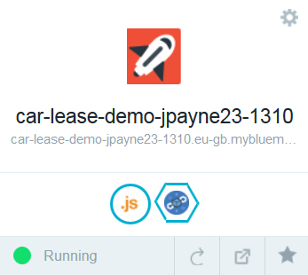 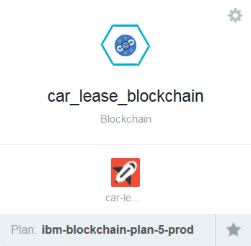

|  |  |
| --- | --- |
| sign-caution | If these services exist then go to step 11! |

Click  against the Car Lease demo. Log in to Bluemix again if necessary.

|  |  |
| --- | --- |
| sign-info | The first time a Bluemix ID creates a sample, a new DevOps alias is required. **Pick a unique ID** and click acceptance of the terms and then click create. For Proof-of-Technology workshops, use the first part of the email address, for example ibmpot000101 (without the ‘+’ character). Then click continue on the following page. |



Leave the App Name, Region, Organization and Space default and click . (You might first need to wait a few seconds for the default field values to be populated.)  
  
Clicking Deploy will cause the car leasing demo to be deployed into your Bluemix environment, and may take a couple of minutes to complete.  
  
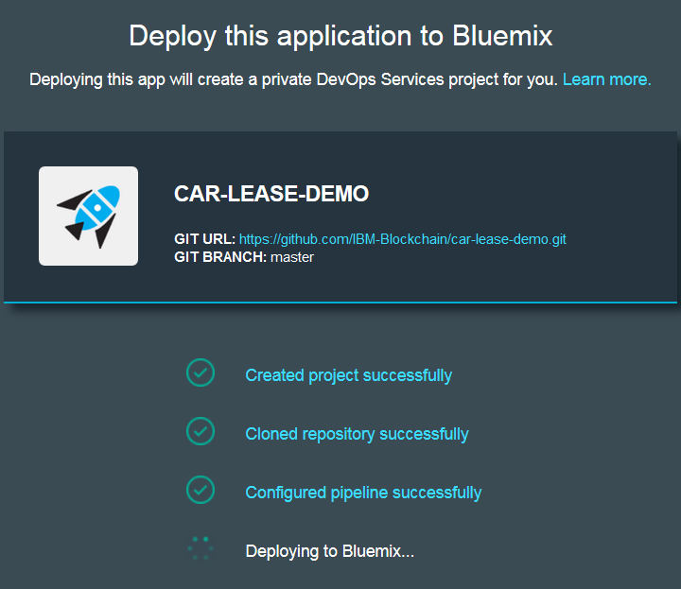

Once you see the ‘Success!’ message click  to see the new car leasing application (and associated Blockchain service) you created.

Click the application’s icon in the dashboard (**your icon may vary**)

  
  
This will show you information about the application, including the memory that it is consuming and activity log.

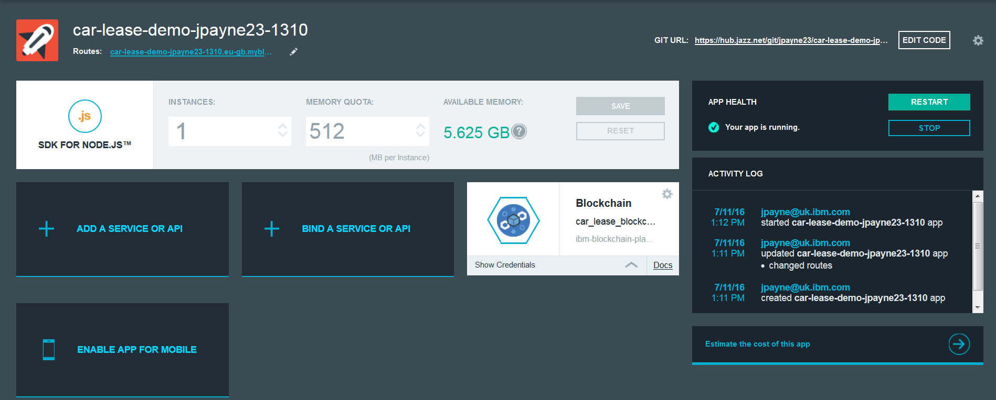

## Starting the Sample Application

1. Click the ‘Routes’ URL (something like ) in order to run the scenario.

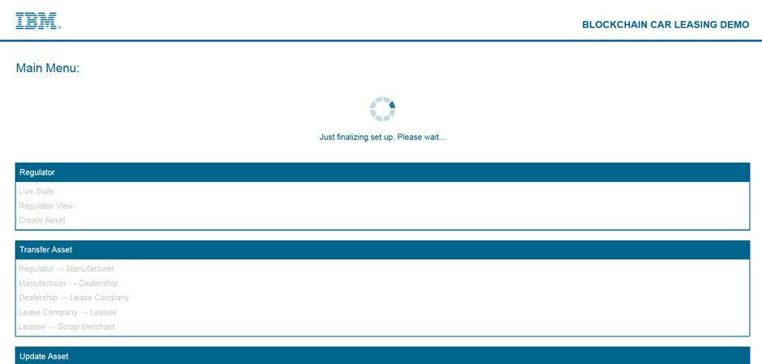

You may see the screen above. This means that the application is not ready to be used yet. Wait until the loading image is gone and you will be presented with the screen shown below.

|  |  |
| --- | --- |
| sign-caution | If running this lab as part of the Proof-of-Technology workshop, and the sample has been created, you should now move to Section 2. |

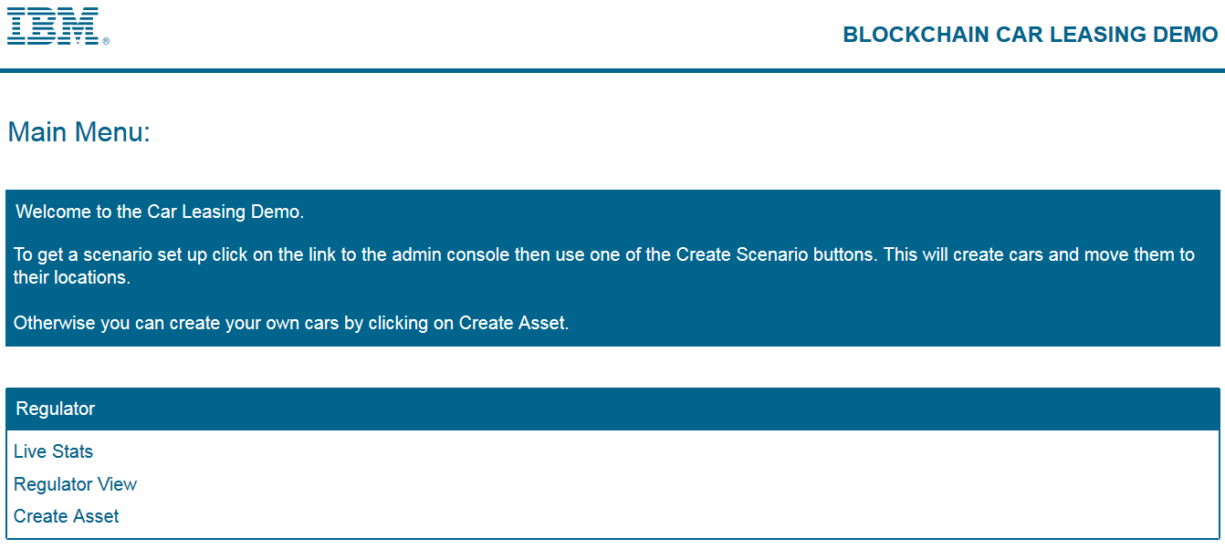

Click ‘Admin Console’ and then ‘Create Simple Scenario’ to load the initial set of assets into the Blockchain. This will take several minutes to complete.

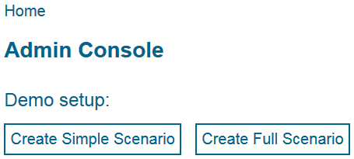

The scenario setup is complete when ‘Demo setup’ is displayed.

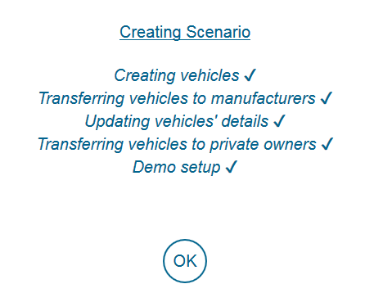

|  |  |
| --- | --- |
| sign-troubleshooting | If an error occurs during creating the scenario, go to Appendix A for instructions on how to delete the service. |

# Asset Transfer and Disposal Scenarios

In the following sections, you will discover how Blockchain technology is used to track ownership of an asset across multiple parties. The scenario describes how Blockchain technology is used to model the lifecycle of vehicle ownership and control between the following participants:

1. Manufacturer to Dealership
2. Dealership to Leasing Company
3. Leasing Company to Leasee
4. Leasing Company to Scrap Merchant

The Scrap Merchant’s role in this scenario will also demonstrate how asset disposal can be represented using Blockchain technology.

In this business scenario each participant has entered into a business agreement with each other and all parties are known and trusted by each other. The above process of transferring vehicles has been negotiated and agreed with all participants. As a result the order in which the above processes take place is strictly defined within the demo showing that for example a Manufacturer cannot transfer directly to a Leasee by missing out the dealership and Leasing company transfers.

This demo has been simplified so that by default each role (e.g. “Manufacturer”) will only show one participant (e.g. “Alfa Romeo”) in the transfer assets page.

## Starting the Asset Transfer Demo

1. Bring up a web browser and go to the URL that your instructor has provided. (If you completed Section 1, just use the URL of the application that you already created.)

|  |  |
| --- | --- |
| sign-troubleshooting | It is recommended to use Firefox or Chrome.  Some people have previously reported problems working with Bluemix in Internet Explorer and Safari. |

You should be able to see the home page of the car leasing demo.

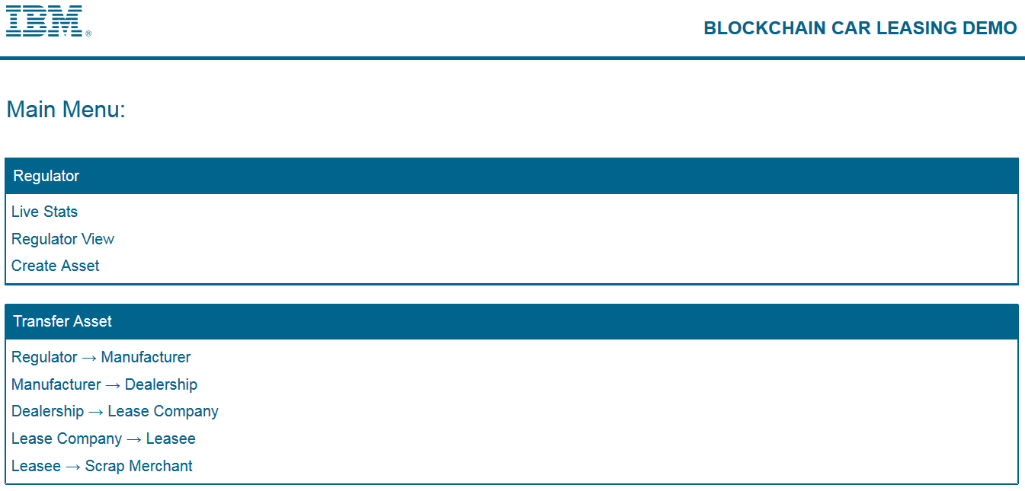

## Scenario: Transfer: Manufacturer to Dealership

In the following section you will transfer the ownership of a vehicle from a Manufacturer to a dealership (known as “Beechvale Group”) using the Blockchain.

Before transferring the vehicle to the dealership you will verify which assets the target dealership currently owns.

### Verify the target Dealership Assets

In this section, you will act as a dealership and verify which assets the Beechvale dealership owns which is permitted to transfer.

|  |  |
| --- | --- |
|  | From the main demo asset page, click the “Dealership -> Lease Company link” : |
|  | In the Dealership Transfer window, click the plus sign in the “Vehicles” window to verify which vehicles are owned by the dealership known as “Beechvale Group” according to the Blockchain.  The demo asset interrogates the Blockchain to identify all vehicles owned by the dealership and will present a window with the results (note the dealership user “Deborah” will only see vehicles owned by the dealership). |
|  | In the results window, verify the number of cars and their make. Note the number in the first column of this table is used to model the Vehicle Identification Number (or VIN).    According to the Blockchain, the Beechvale dealership owns 3 cars (none of which are Alfa Romeo’s).  Click the cross to dismiss the window. |
|  | Press Cancel on the dealership page to return to the Main demo menu:  You will now transfer an Alfa Romeo car to the Beechvale Dealership, from the cars owned by Alfa Romeo (the Manufacturer). |

### Transfer the asset (from Manufacturer to Dealership)

|  |  |
| --- | --- |
|  | From the demo main menu, click the “Manufacturer -> Dealership” link in the Transfer Asset section: |
|  | The Transfer Asset window shows an identity “Martin” (the manufacturer of Alfa Romeo vehicles).  Click the plus sign in the Vehicles box: |
|  | The demo asset collects details from the Blockchain on cars that Martin (the Alfa Romeo manufacturer) owns and presents the results:    Click the check box of the first car in the list to include it in the transfer request.  Click the checkmark at the bottom of the list of vehicles to save the choice. |
|  | The Alfa Romeo with VIN number “**880352730316924**” now appears in the list of vehicles to be transferred:  Click the plus sign in the Dealership box. |
|  | From the list of Dealerships, choose “Beechvale Group” then, click the checkmark to confirm your choice): |
|  | The Transfer menu should now have the following details. Click the “Transfer Assets” button: |
|  | The Demo asset, highlights its activits with the Blockchain in the status window:  The demo asset updates the owner of the contract based on the dealership specified in the transfer request. The demo asset then waits for the open source Blockchain technology to declare “consensus” shown by the stage “Achieving Consensus”. Once consensus is achieved the transfer request is “committed” to the blockchain. We then confirm the information update has been succesful, as shown by the confirmation “Owner Updated”. |
|  | Click OK to acknowledge the transfer status messages. |
|  | Click the checkmark to acknowledge the Transaction Complete message: |

### Verify Manufacturer has no control over Transferred Asset

|  |  |
| --- | --- |
|  | The manufacturer’s ability to control the asset has now been removed. Click the plus sign on the Vehicles box to verify that the manufacturer can no longer see the asset you transferred: |
|  | The manufacturer now controls only three assets, the transferred vehicle is no longer visible to the manufacturer. Click the cross mark to dismiss the window. |

## Scenario: View the Blockchain Activity

|  |  |
| --- | --- |
|  | From the Demo asset main menu, click the Live stats link: |
|  | The Blockchain statistics page shows the transfer activity as a vertical bar in the Transactions window:  stats_page  **Last Block:** The block number is of the last committed block  **Created:** How long ago since the last block was committed  **Transactions in Last Block:** The number of transactions in the last block  **Avg Block Time:** The average time between each block being committed  **Block Time Graph:** A graph showing how much time was between each block – also showing ‘Block 0’ if the scale allows  **Transactions Per Block -** **Graph**: How many transactions were in each Block – also showing ‘Block 0’ if the scale allows  **Blockchain Explorer**: Allows you to look at a specific block’s details in the Blockchain. More detailed explanation in Lab 02. |

## Scenario: Transfer: Dealership to Leasing Company

In this section you will act as “the dealer”. First, you will verify that the asset you transferred earlier is now available to you to transfer; you will then transfer the asset to the leasing company.

### Verify the Dealership can now control the Asset

In the previous section you transferred the ownership of the vehicle **880352730316924** from the Alfa Romeo manufacturer to the dealership “Beechvale Group”. The vehicle will now appear in the list of vehicles Beechvale Group are able to control.

|  |  |
| --- | --- |
|  | From the demo “Regulator View” click Main Menu, then click the “Dealership -> Lease Company” link: |
|  | In the Dealership page, click the plus sign in the “Vehicles” box to show the list of vehicles controlled by the dealer, you should see the vehicle **880352730316924** is now under the control of the dealership:  Select the vehicle 880352730316924 and click the tick at the bottom of the screen. |
|  | In the Lease Company window click the plus sign to add “LeaseCan” Lease Company window: |
|  | Check the Vehicle and Lease Company details are correct, then click the “Transfer Assets” button: |
|  | As with the previous transfer the demo extracts the contract details used to define the vehicle, updates the owner, waits for consensus to be achieved then confirms the update was successful, as shown by the message “Owner Updated”:  Click OK. |
|  | Dismiss the Transaction Complete message by clicking the checkmark: |
|  | Click the plus sign in the “Vehicles” box to verify that the asset is no longer available to the Beechvale group dealer. You now will see only three vehicles. The vehicle you just transferred to the lease company should not appear: |
|  | Close this window and “Cancel” out of the Dealership’s Transfer Assets page. |

## Scenario: Transfer: Lease Company to Leasee

In this section, you will act as the lease company. First, you will verify that the asset you transferred earlier is now available to you acting as the lease company to transfer; you will then transfer the asset to a leasee.

### Verify the Lease Company can now control the Asset

In the previous section, you transferred the ownership of the vehicle **880352730316924** from the dealership “Beechvale Group” to the lease company “LeaseCan”. The vehicle will now appear in the list of vehicles LeaseCan are able to control.

|  |  |
| --- | --- |
|  | From the demo Main Menu, click the “Lease Company -> Leasee” link: |
|  | Use the plus signs to prepare a transfer as follows Click the transfer Assets button when ready: |
|  | When a consensus has been achieved click the OK button. |
|  | Dismiss the Transaction Complete message by clicking the checkmark. |
|  | Verify that the vehicle is no longer available to the lease company (click the plus sign in the vehicles box, the vehicle **880352730316924** should not appear in the list of vehicles). |

## Scenario: Transfer: Leasee to Scrap Merchant

In this section, you will act as the leasee (individual). First, you will verify that the asset you transferred earlier is now available to you acting as the Leasee to transfer; you will then transfer the asset to a scrap merchant.

### Verify the Leasee can now control the Asset

In the previous section, you transferred the ownership of the vehicle **880352730316924** from the lease company “LeaseCan” to the individual “Joe Payne”. The vehicle will now appear in the list of vehicles Joe is able to control.

|  |  |
| --- | --- |
|  | From the demo Main Menu, click the “Lease Company -> Leasee” link: |
|  | Use the plus signs to prepare a transfer as follows, click the Transfer Assets button when ready: |
|  | When a consensus has been achieved click the OK button. |
|  | Dismiss the Transaction Complete message by clicking the checkmark. |
|  | Verify that the vehicle is no longer available to Joe Payne (click the plus sign in the vehicles box, the vehicle **880352730316924** should not appear in the list of vehicles). |

## Scenario: Scrap Merchant - Asset disposal

In this section, you will act as the scrap merchant (individual) and dispose of the asset. First, you will verify that the asset you transferred earlier is now available to you acting as the scrap merchant. You will then dispose of the asset.

### Verify the Scrap Merchant can control the Asset

In the previous section, you transferred the ownership of the vehicle **8803527303169234** from “Joe Payne” to the scrap merchant. The vehicle will now appear in the list of vehicles that the scrap merchant is able to control.

|  |  |
| --- | --- |
|  | From the demo Main Menu, click the “Scrap Merchant -> Scrap” link: |
|  | Use the plus sign to prepare for the disposal of the asset as follows, click the “Scrap Assets” button when ready (note there is no destination on this screen): |
|  | When a consensus has been achieved click the OK button. |
|  | Dismiss the Transaction Complete message by clicking the checkmark. |
|  | Verify that the vehicle is no longer available to the scrap merchant (click the plus sign in the vehicles box, the vehicle **880352730316924** should not appear in the list of vehicles). |

## Scenario: Verify Transaction activity using the Regulator view

In this section you will act as the Regulator and view the asset transfer and disposal activity you have performed above.

The regulator view has unrestricted access to all activities on the Blockchain.

|  |  |
| --- | --- |
|  | From the demo Main Menu, click the “Regulator View” link. Wait for the view to gather the activity from the Blockchain. |
|  | When the list of transactions are shown on the screen, you will see the activity in chronological order (with the most recent activity at the top of the list of transactions):  Note the regulator can see *all* Blockchain transactions. The whole history of the vehicle can be seen in this view snd can be seen by the same vehicle previously created by Alfa Romeo before. |
|  | Copy the V5C ID **DA6060712** and use the search feature to show only the history of the one vehicle: |
|  | Other users can only see part of the lifecycle of the vehicle. They are able to see what happened to the vehicle prior to their ownership and whilst they owned it but cannot see what happened to the vehicle after they transferred it.  Click the three lines in the top right corner of the page to view the leder as another user. In the dropdown that appears hover over “Lease Companies” then click “Lease Can”. |
|  | regulator_lease_companyThe table has now changed and although the user can see the car they can’t see what happened after it was transferred to “Joe Payne”. |
|  | Copy The V5C ID **DA6060712** and use the search feature to show only the history of the one vehicle:  As you can see the user can see the entrire lifecycle of the car from before they owned it up until they transferred it. |

1. Removing the sample application

This appendix shows how to stop and remove the Blockchain service you created.

1. Return to the Bluemix Dashboard by clicking .
2. Click the Settings icon in the car lease demo application.



1. Select ‘Delete App’ from the menu.
2. Ensure that the ‘car\_lease\_blockchain’ service is selected for deletion and click ‘Delete’.

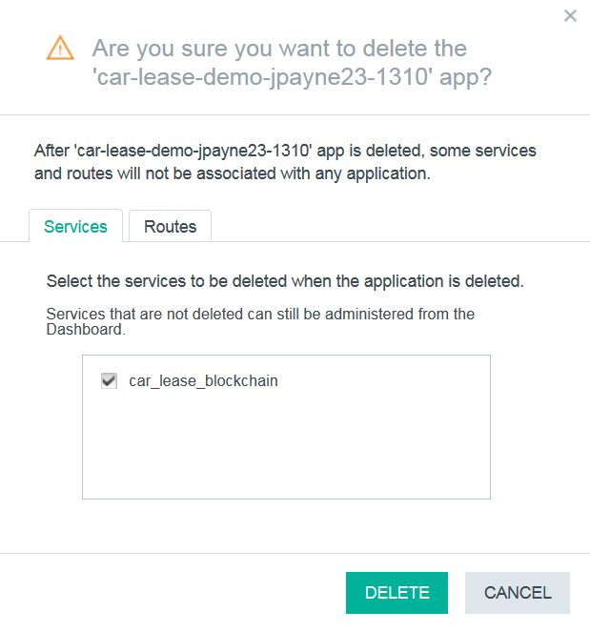

1. Wait for the items to be stopped and deleted. Once this is done, both the application and the associated service will no longer be visible in the Bluemix dashboard.
2. Notices

This information was developed for products and services offered in the U.S.A.

IBM may not offer the products, services, or features discussed in this document in other countries. Consult your local IBM representative for information on the products and services currently available in your area. Any reference to an IBM product, program, or service is not intended to state or imply that only that IBM product, program, or service may be used. Any functionally equivalent product, program, or service that does not infringe any IBM intellectual property right may be used instead. However, it is the user's responsibility to evaluate and verify the operation of any non-IBM product, program, or service.

IBM may have patents or pending patent applications covering subject matter described in this document. The furnishing of this document does not grant you any license to these patents. You can send license inquiries, in writing, to:

IBM Director of Licensing  
IBM Corporation  
North Castle Drive  
Armonk, NY 10504-1785  
U.S.A.

For license inquiries regarding double-byte (DBCS) information, contact the IBM Intellectual Property Department in your country or send inquiries, in writing, to:

IBM World Trade Asia Corporation  
Licensing  
2-31 Roppongi 3-chome, Minato-ku  
Tokyo 106-0032, Japan

**The following paragraph does not apply to the United Kingdom or any other country where such provisions are inconsistent with local law:** INTERNATIONAL BUSINESS MACHINES CORPORATION PROVIDES THIS PUBLICATION "AS IS" WITHOUT WARRANTY OF ANY KIND, EITHER EXPRESS OR IMPLIED, INCLUDING, BUT NOT LIMITED TO, THE IMPLIED WARRANTIES OF NON-INFRINGEMENT, MERCHANTABILITY OR FITNESS FOR A PARTICULAR PURPOSE. Some states do not allow disclaimer of express or implied warranties in certain transactions, therefore, this statement may not apply to you.

This information could include technical inaccuracies or typographical errors. Changes are periodically made to the information herein; these changes will be incorporated in new editions of the publication. IBM may make improvements and/or changes in the product(s) and/or the program(s) described in this publication at any time without notice.

Any references in this information to non-IBM Web sites are provided for convenience only and do not in any manner serve as an endorsement of those Web sites. The materials at those Web sites are not part of the materials for this IBM product and use of those Web sites is at your own risk.

IBM may use or distribute any of the information you supply in any way it believes appropriate without incurring any obligation to you.

Any performance data contained herein was determined in a controlled environment. Therefore, the results obtained in other operating environments may vary significantly. Some measurements may have been made on development-level systems and there is no guarantee that these measurements will be the same on generally available systems. Furthermore, some measurements may have been estimated through extrapolation. Actual results may vary. Users of this document should verify the applicable data for their specific environment.

Information concerning non-IBM products was obtained from the suppliers of those products, their published announcements or other publicly available sources. IBM has not tested those products and cannot confirm the accuracy of performance, compatibility or any other claims related to non-IBM products. Questions on the capabilities of non-IBM products should be addressed to the suppliers of those products.

All statements regarding IBM's future direction and intent are subject to change or withdrawal without notice, and represent goals and objectives only.

This information contains examples of data and reports used in daily business operations. To illustrate them as completely as possible, the examples include the names of individuals, companies, brands, and products. All of these names are fictitious and any similarity to the names and addresses used by an actual business enterprise is entirely coincidental. All references to fictitious companies or individuals are used for illustration purposes only.

COPYRIGHT LICENSE:

This information contains sample application programs in source language, which illustrate programming techniques on various operating platforms. You may copy, modify, and distribute these sample programs in any form without payment to IBM, for the purposes of developing, using, marketing or distributing application programs conforming to the application programming interface for the operating platform for which the sample programs are written. These examples have not been thoroughly tested under all conditions. IBM, therefore, cannot guarantee or imply reliability, serviceability, or function of these programs.

1. Trademarks and copyrights

The following terms are trademarks of International Business Machines Corporation in the United States, other countries, or both:

|  |  |  |  |  |  |  |
| --- | --- | --- | --- | --- | --- | --- |
| IBM | AIX | CICS | ClearCase | ClearQuest | Cloudscape |  |
| Cube Views | DB2 | developerWorks | DRDA | IMS | IMS/ESA |  |
| Informix | Lotus | Lotus Workflow | MQSeries | OmniFind |  |  |
| Rational | Redbooks | Red Brick | RequisitePro | System i |  |  |
| *System z* | *Tivoli* | *WebSphere* | *Workplace* | *System p* |  |  |

Adobe, the Adobe logo, PostScript, and the PostScript logo are either registered trademarks or trademarks of Adobe Systems Incorporated in the United States, and/or other countries.

IT Infrastructure Library is a registered trademark of the Central Computer and Telecommunications Agency which is now part of the Office of Government Commerce.

Intel, Intel logo, Intel Inside, Intel Inside logo, Intel Centrino, Intel Centrino logo, Celeron, Intel Xeon, Intel SpeedStep, Itanium, and Pentium are trademarks or registered trademarks of Intel Corporation or its subsidiaries in the United States and other countries.

Linux is a registered trademark of Linus Torvalds in the United States, other countries, or both.

Microsoft, Windows, Windows NT, and the Windows logo are trademarks of Microsoft Corporation in the United States, other countries, or both.

ITIL is a registered trademark, and a registered community trademark of The Minister for the Cabinet Office, and is registered in the U.S. Patent and Trademark Office.

UNIX is a registered trademark of The Open Group in the United States and other countries.

Java and all Java-based trademarks and logos are trademarks or registered trademarks of Oracle and/or its affiliates.

Cell Broadband Engine is a trademark of Sony Computer Entertainment, Inc. in the United States, other countries, or both and is used under license therefrom.

Linear Tape-Open, LTO, the LTO Logo, Ultrium, and the Ultrium logo are trademarks of HP, IBM Corp. and Quantum in the U.S. and other countries.



© Copyright IBM Corporation 2016.

The information contained in these materials is provided for informational purposes only, and is provided AS IS without warranty of any kind, express or implied. IBM shall not be responsible for any damages arising out of the use of, or otherwise related to, these materials. Nothing contained in these materials is intended to, nor shall have the effect of, creating any warranties or representations from IBM or its suppliers or licensors, or altering the terms and conditions of the applicable license agreement governing the use of IBM software. References in these materials to IBM products, programs, or services do not imply that they will be available in all countries in which IBM operates. This information is based on current IBM product plans and strategy, which are subject to change by IBM without notice. Product release dates and/or capabilities referenced in these materials may change at any time at IBM’s sole discretion based on market opportunities or other factors, and are not intended to be a commitment to future product or feature availability in any way.

IBM, the IBM logo and ibm.com are trademarks of International Business Machines Corp., registered in many jurisdictions worldwide. Other product and service names might be trademarks of IBM or other companies. A current list of IBM trademarks is available on the Web at “Copyright and trademark information” at www.ibm.com/legal/copytrade.shtml.

